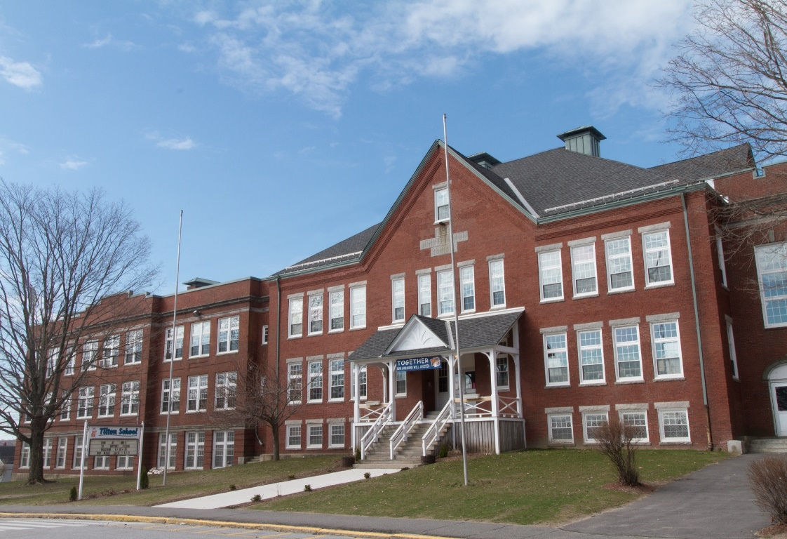

MINIMUM CAPACITY :-

The Minumum intake capacity

of students is between 300-620

children

LIBRARY :-

The Libarary is Available.

CANTEEN:-

The Canteen Facility is Available.

BOARDING :-

No availablility of boarding.

SPORTS :-

There are different categories

sports available.

Girls Volleyball

Boys Volleyball

Football

|  |  |  |
| --- | --- | --- |
| TILTON SCHOOL  UTICA - SCHOOL |  |  |
|  |  |  |
| School Detail :- Tilton is a New Hampshire prep school that prepares students to embrace and navigate a world driven by diversity and change. Through the quality of human relationships, Tilton’s community cultivates in its students the curiosity, the skills, the knowledge and understanding, the character, and the integrity requisite for the passionate pursuit of lifelong success and service.  Tilton’s community cultivates in its students the curiosity, the skills, the knowledge and understanding, the character, and the integrity requisite for the passionate pursuit of lifelong success and service. |  |